Locators in Selenium

First screenshot showing 7 locators and it usage priority.

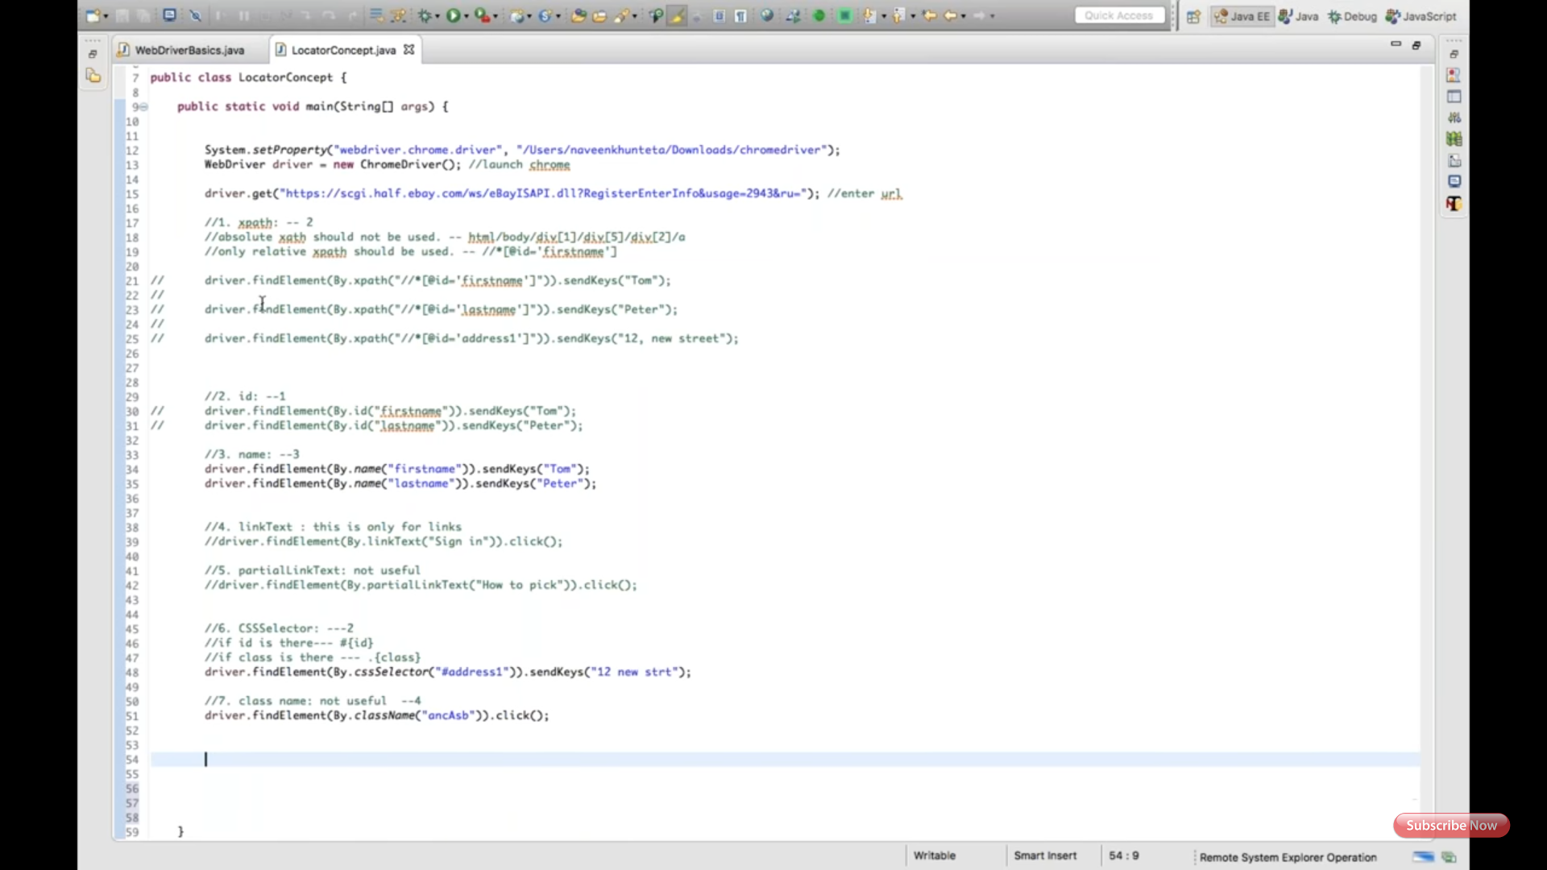

Second screenshot showing how Select class used to select drop-down value.

